CFIHOS – Specification Document

Version | Date | Comments/History
1.4 | 2020-04 | IOGP republication of CFIHOS document first published in October 2019.
1.4.1 | 2020-12 | New sections added:  2. ‘Purpose and Objectives’ (previously part of section 1. Scope)  8. ‘Models’
1.5 | 2021-10 | Broadened PDF requirements to include scans or renderings in section 7.4.5. Updated Annex A.2 Figure 3 to include process, streams and classes and section 6.2 to reference all figures in Annex A.2.
1.5.1 | 2022-11 | Minor text changes for bug fixes throughout the text of the document. Added ISO 8601 reference
2.0 | 2024-10-31 | Completely reformatted into requirements document to support use of requirements management tools

Acknowledgements

In 2012, Shell approached Netherlands-based process industry organization USPI to explore turning their corporate information standard into an industry-wide standard. The result was the CFIHOS (Capital Facilities Information Handover Specification) project.

Its aim is to offer practical, standardized specifications for information handover that work across the supply chain – operators, contractors and suppliers. The most recent CFIHOS industry standard (Version 1.4) was published in October 2019 by USPI with support from the Engineering Advancement Association of Japan (ENAA). This document, describing the scope and procedures of CFIHOS, is part of this specification.

Following a member vote in 2019, the future governance, development, and maintenance of the CFIHOS project and standard moved from USPI to IOGP in January 2020, becoming Joint Industry Project (JIP)36.

Disclaimer
Whilst every effort has been made to ensure the accuracy of the information
contained in this publication, neither IOGP nor any of its Members past present or
future warrants its accuracy or will, regardless of its or their negligence, assume
liability for any foreseeable or unforeseeable use made thereof, which liability is
hereby excluded. Consequently, such use is at the recipient’s own risk on the basis
that any use by the recipient constitutes agreement to the terms of this disclaimer.
The recipient is obliged to inform any subsequent recipient of such terms.
This publication is made available for information purposes and solely for the private
use of the user. IOGP will not directly or indirectly endorse, approve or accredit the
content of any course, event or otherwise where this publication will be reproduced.

Copyright notice
The contents of these pages are © International Association of Oil & Gas Producers.
Permission is given to reproduce this report in whole or in part provided (i)
that the copyright of IOGP and (ii) the sources are acknowledged. All other rights are
reserved. Any other use requires the prior written permission of IOGP.
These Terms and Conditions shall be governed by and construed in accordance
with the laws of England and Wales. Disputes arising here from shall be exclusively
subject to the jurisdiction of the courts of England and Wales.

Foreword
The Capital Facilities Information Handover Specification (CFIHOS) is an industry standard developed to improve how technical information is exchanged between principals, contractors and suppliers/manufacturers for the process and energy sectors. Starting with a common engineering dictionary and supporting specifications, the CFIHOS goal is to become a common language for the exchange of technical information in these sectors.

CFIHOS is being developed collaboratively by principal (owner/operator) companies, EPC Contractors, software providers and equipment vendors/suppliers/manufacturers as a practical standard to ensure the systematic and reliable exchange of information among all companies involved in the data supply chain, thereby reducing cycle times and costs.

The initial focus is on the information, as computer models, structured data and traditional document formats, are handed over when a project moves from its development to operations phase. Ultimately, the aim is for CFIHOS to become the de-facto standard for information exchange throughout the physical asset lifecycle, from vendor information through to decommissioning.
Table of Contents
Foreword 3
1 Scope 6
1.1 Inclusions 6
1.2 Exclusions 6
1.3 Purpose 7
2 Normative References 7
3 Terms, Definitions and Abbreviated Terms 8
3.1 Terms and Definitions 8
3.2 Abbreviated Terms 11
4 Applicable Standards and Documents 12
4.1 Overview 12
4.2 International Standards 12
4.3 CFIHOS C-ST-001, CFIHOS Reference Data Library (RDL) 13
5 Data 14
5.1 Data Specification 14
5.2 Application Neutral Data 14
5.3 Application Specific Data 14
5.4 Plant Breakdown Structure 14
5.5 Process, Streams, and Cases 15
5.6 Tag and Equipment Class Properties 15
5.7 Data Specification 16
6 Documents 18
6.1 General 18
6.2 Document Specification 19
6.3 Document Numbering 19
6.4 Discipline 20
6.5 Document Type Classification 20
6.6 Discipline Document Type Classification 20
6.7 Document Metadata 21
6.8 Document Books (or Binders) 21
6.9 File Requirements 22
6.10 Additional Files 23
6.11 Files to be Delivered 24
6.12 Image Quality 25
6.13 Hyperlinks 26
6.14 Different Languages 26
6.15 Character Set 27
6.16 Document Size 27
6.17 Document References 28
6.18 Physical Record Requirements 28
7 Application Specific Databases 28
7.1 Application Specific Databases 28
Annex A - Information Specification 31
A.1 General 31
A.2 Data Model 31
A.3 Data Dictionary 36
A.4 Application Specific Data 38
Bibliography 41

List of Tables
Table A.1 – Data Dictionary Descriptions 37
Table A.2 – Application Specific Database Examples 39

List of Figures
Figure A.1 – High-level overview of the complete model 34
Figure A.2 – Overview of the Plant Breakdown Structure 34
Figure A.3 – Overview of the Classifications and Properties including Processes, Streams and Cases 35
Figure A.4 – Overview of the document management metadata 35
Figure A.5 – Overview of metadata requirements at time of procurement 36

Introduction

This document provides the requirements for engineering information handover specification for capital facilities between principals, contractors and suppliers/manufacturers. It specifies the engineering information principals require for future operation and maintenance of their facilities.
CFIHOS Implementation Guide for Principal [C-GD-001] and CFIHOS Implementation Guide for Contractor [C-GD-002] provide detailed guidance on how to use this specification.

The CFIHOS unique ID can be found at the start of each requirement, CFIHOS-SPTR-0001.

1 Scope
CFIHOS-SPTR-1

1.1 Inclusions

This specification covers the following:
a) handover of information for production facilities;
b) handover of information along the process industry plant engineering supply chain that consists of principals, contractors, and suppliers/manufacturers where the following applies:

1. The principal is the end client company that owns the production facility and is responsible for operation and maintenance.
2. The contractor is responsible for design, detailed engineering, procurement, construction and commissioning of a facility.
3. The maintenance contractor maintains and/or operates the facility.
4. The supplier/manufacturer delivers the equipment used to construct a facility and is responsible for the design, manufacturing and assembly of a particular piece of equipment.
c) part of engineering information created by the contractor and the supplier/manufacturer required by the principal to operate and maintain a facility and to support future design changes.

CFIHOS-SPTR-2

1.2 Exclusions
The scope of this specification excludes the following:

a) engineering information created by the contractor and the supplier/manufacturer that is not required by the principal to operate and maintain a facility or to support any future design changes;
b) processes that govern how the contractor or the supplier/manufacturer creates and/or quality assures the engineering information;
c) systems used to develop the information nor the systems in which the information will be quality assured and stored at handover.

CFIHOS-SPTR-3

1.3 Purpose
The purpose of this document is to create a standard specification for principals, contractors and suppliers/manufacturers for the handover of engineering information in a facilities project, such that:
a) this specification is an integral part of the full set of specifications which specifies the physical plant and information required

b) the information satisfies:
1. information requirements from statutory authorities;
2. approval and acceptance of delivery by the involved stakeholders;
3. design for future changes to the plant;
4. operation and maintenance during the lifetime of the plant;

c) the specification can be applied across the supply chain

2 Normative References
The following documents are referred to in the text in such a way that some or all of their content constitutes requirements of this document. For dated references, only the edition cited applies. For undated references, the latest edition of the referenced document (including any amendments) applies.
CFIHOS-NR-1
CFIHOS C-DM-001, CFIHOS Data Model
CFIHOS-NR-2
CFIHOS C-DM-002, CFIHOS Data Dictionary
CFIHOS-NR-3
CFIHOS C-GD-001, CFIHOS Implementation Guide for Principal
CFIHOS-NR-4
CFIHOS C-GD-002, Implementation Guide for Contractor
CFIHOS-NR-5
CFIHOS C-ST-001, CFIHOS Reference Data Library (RDL)
CFIHOS-NR-6
CFIHOS C-TP-001, CFIHOS Scope and Procedure
CFIHOS-NR-7
ISO 8601-1, Date and time — Representations for information interchange — Part 1: Basic rules
CFIHOS-NR-8
ISO 216, Writing paper and certain classes of printed matter – trimmed size
CFIHOS-NR-9
ISO 5457, Technical product documentation, sizes and layout of drawing sheets
CFIHOS-NR-10
ISO 3166-1, Codes for the representation of names of countries and their subdivisions
CFIHOS-NR-11
ISO/IEC 10646, Information technology – universal coded character set (UCS)
CFIHOS-NR-12
ISO/IEC 8859-15, Information technology – 8-bit single-byte coded graphic character sets

3 Terms, Definitions and Abbreviated Terms

3.1 Terms and Definitions
CFIHOS-DEF-1
3.1.1
additional files
logical collection of physical computer files that are associated to one document revision identification
CFIHOS-DEF-2
3.1.2
application
computer program designed to help people perform an activity
CFIHOS-DEF-3
3.1.3
application neutral data
data that should be specified and exchanged using an industry standard that is independent of specific software (e.g. CFIHOS, DEXPI etc.)
CFIHOS-DEF-4
3.1.4
application specific data
data that cannot be specified and exchanged using an industry standard, which instead necessitates data exchange based on proprietary software format
CFIHOS-DEF-5
3.1.5
approved for construction
formal milestone indicating the start of construction/erection activities. Information assigned this status should be used to support construction activities
CFIHOS-DEF-6
3.1.6
as-built
describing documentation, data and models associated with the facility, system or component that represents the actual physical “as is” situation
CFIHOS-DEF-7
3.1.7
as-design
documentation, data and models associated with the facility, system or component that represents the initial design and subsequently incorporates all approved design changes
CFIHOS-DEF-8
3.1.8
contract information management scope of work
document in which the principal specifies the terms and conditions for information delivery by the contractor. Where it is applicable and feasible, quality benchmarks and criteria to fulfil them should be included
CFIHOS-DEF-9
3.1.9
contract RDL
document in which the principal specifies the requirements of the RDL specific for the scope of contract based on the CFIHOS RDL and should include deviations from or additions to the CFIHOS RDL [C-ST-001]
CFIHOS-DEF-10
3.1.10
contractor
party that carries out all or part of the design, engineering, procurement, construction, commissioning or management of a project or operation of a facility
CFIHOS-DEF-11
3.1.11
controlled document
digital or hardcopy entity which is required by a company, a standards organization, or a regulatory agency to be managed within a tightly controlled process that maintains the integrity of its content through revision control
CFIHOS-DEF-12
3.1.12
discipline document type
association between disciplines and document class names. In the CFIHOS context, this is a unique identifier for types of documents and has been developed for situations where a document class is common to more than one discipline. For example, a process engineering flow scheme should only be produced by the process discipline, whereas a data sheet could be produced by many disciplines depending on the equipment where each discipline is responsible for part of the content
CFIHOS-DEF-13
3.1.13
export control classification number (ECCN)
alphanumeric code that identifies the level of export control for articles, technology, and software (collectively, "Items") that are exported from member states of the Wassenaar Arrangement on Export Controls for Conventional Arms and Dual-Use Goods and Technologies, including the United States. The ECCN classification that applies to any specific item is determined by referring to a table such as that issued for the United States by the Bureau of Industry and Security and for Europe by Regulation 428/2009
CFIHOS-DEF-14
3.1.14
facility plant
land, buildings, machinery, apparatus, and fixtures employed in carrying on a trade or an industrial business
CFIHOS-DEF-15
3.1.15
handover of information
formal process between the principal and the contractor for transfer of ownership and responsibility for the change management of information aligned with the official acceptance of a physical facility
CFIHOS-DEF-16
3.1.16
handover plant breakdown structure
plant breakdown structure that structures the handover deliverables in relation to the physical assets
CFIHOS-DEF-17
3.1.17
maintenance contractor
a party that maintains the plant on behalf of the principal
CFIHOS-DEF-18
3.1.18
master document register (MDR)
list of documents and drawings items the principal would like to trace e.g. have technical documentation and meta-data available, during the lifetime of an industrial plant
CFIHOS-DEF-19
3.1.19
master tag register (MTR)
list of tagged items the principal would like to trace e.g. have technical data and documentation available, during the lifetime of an industrial plant

CFIHOS-DEF-20
3.1.20
original equipment manufacturer (OEM)
company that originally manufactured the equipment item and from which the equipment supplier purchased the equipment ultimately for the principal’s use
CFIHOS-DEF-21
3.1.21
principal
party that initiates the project and ultimately pays for it, including any agent or consultant authorized to act for, and on behalf of, the principal
CFIHOS-DEF-22
3.1.22
reference data library (RDL)
standard and unified naming convention for equipment classification, its properties, disciplines, and documents, a set of information requirement specifications for documents and tagged items
CFIHOS-DEF-23
3.1.23
shall
used to indicate that a provision is mandatory, i.e it is a requirement
CFIHOS-DEF-24
3.1.24
should
is used to indicate that a provision is not mandatory, i.e it is recommended as good practice
CFIHOS-DEF-25
3.1.25
supplier manufacturer
party that manufactures or supplies equipment and services to perform the duties specified by the contractor. The supplier/manufacturer should be the contractor where the principal is the end consumer of the equipment/service

3.2 Abbreviated Terms
CFIHOS-AAS-1
DEXPI
Data Exchange in the Process Industry
CFIHOS-AAS-2
FL3DMS
Facility Lifecycle 3D Modeling Standard
CFIHOS-AAS-3
OCR
optical character recognition

4 Applicable Standards and Documents
CFIHOS-SPTR-4

4.1 Overview
This section describes the applicable standards and practices relevant to this document in specifying what information is handed over to the principal.
CFIHOS-SPTR-5

4.2 International Standards
International standards relevant to this area of work include 4.2 a) I through 4.2 i):

a) ISO 10303 is also known as STEP or the “Standard for the Exchange of Product model data”. It is a standard for the computer-deciphered representation and exchange of industrial product data. The objective is to provide a mechanism capable of describing product data throughout the life cycle of a product, independent from a particular system.

b) ISO 14224 provides a comprehensive basis for the collection of Reliability and Maintenance (RM) data in a standard format for equipment in all facilities and operations within the petroleum, natural gas and petrochemical industries during the operational life cycle of equipment.
c) ISO 15926 specifies a conceptual data model for computer representation of technical information about process plants.
d) ISO 8601-1 specifies a standard date format of YYYY-MM-DD.
e) ISO 216 and ISO 5457 specifies the document and drawing standard sheet sizes.
f) ISO 4217 specifies the structure for a three-letter alphabetic code and an equivalent three-digit numeric code for the representation of currencies. For those currencies having minor units, it also shows the decimal relationship between such units and the currency itself.
g) ISO 3166-1 defines the internationally recognized codes of letters and/or numbers that we can use when we refer to countries and their subdivisions.
h) ISO/IEC 10646 specifies the architecture of the UCS and defines terms for its use.
​​​​​
i) ISO 8859-15 specifies a set of 191 coded graphic characters identified as Latin alphabet No. 9. This set of coded graphic characters is intended for use in data and text processing applications and also for information interchange.

4.3 CFIHOS C-ST-001, CFIHOS Reference Data Library (RDL)
CFIHOS-SPTR-6

4.3.1
The CFIHOS RDL provides a standard and unified naming convention for equipment classification, its properties, disciplines and documents. It is a set of information requirement specifications for documents and tagged items. The CFIHOS RDL contains the following:

a) list of classes for tag and equipment (what the equipment does and what it is);
b) list of properties (attributes, measures, characteristics etc.);
c) lists of requirements by class (data and applicable document references);
d) list of disciplines;
e) list of document types;
f) relationships between data entities;
g) CFIHOS unique ID codes;
CFIHOS-SPTR-7

4.3.2
The contractor shall deliver the plant data and applicable document references in conformance with the contract RDL based on the CFIHOS RDL and other principal specific documents including, engineering, tagging specification and document numbering specification.
CFIHOS-SPTR-8

4.3.3
If updates to the contract RDL or reference data requirements are required, either the contractor shall submit a change request to the principal for approval or the principal shall formally transmit a change notification to the contractor who has the right to review and require a change order as appropriate.
CFIHOS-SPTR-9

4.3.4
When updates to the contract RDL or reference data requirements are made, the contractor shall replace any earlier revisions of the reference data and ensure future compliance with the new revision.
CFIHOS-SPTR-10

4.3.5
By application of the contract RDL, the contractor is able to determine the principal’s information requirements. See the following example:

a) if a tag is classified as a temperature transmitter, the CFIHOS RDL defines which entity attribute and class-specific properties for that temperature transmitter need to be delivered by the contractor. Except for the entity attributes common to all classes, the property requirements would be different if a different classification is used.
b) if a document is classified as a piping and instrumentation diagram, the CFIHOS RDL identifies the final status of the document to be handed over (e.g., as-built), when a native file format is required (at handover, during project or not required) and a document’s representation type (e.g. structured data).

5 Data
CFIHOS-SPTR-11

5.1 Data Specification
Data can be specified in either application neutral data or application specific database.
CFIHOS-SPTR-12

5.2 Application Neutral Data
Deliverables are generated and submitted via file(s) such as CSV or XLSX and make reference to international standards such as CFIHOS and ISO 19008, where applicable. As it is an industry standard, this CFIHOS Specification Document focuses on requirements for application neutral data, which are set out in section 5.
CFIHOS-SPTR-13

5.2.1
The contractor shall hand over all application neutral data in accordance with the contract requirements.
CFIHOS-SPTR-14

5.2.2
The contractor shall ensure that all application neutral data delivered is consistent with corresponding information.
CFIHOS-SPTR-15

5.3 Application Specific Data
The principal should provide a specification or template to enable import/upload of the data into the principal’s application. Requirements for application specific templates are set out in Section 7. Examples of application specific data deliverables, such as for models, are set out in Annex A.4. These deliverables are submitted via native files of the applications used to develop them.
CFIHOS-SPTR-16

5.3.1
The contractor shall hand over all application specific data in accordance with the contract requirements.
CFIHOS-SPTR-17

5.3.2
The contractor shall ensure that all application specific data delivered is consistent with corresponding information.
CFIHOS-SPTR-18

5.4 Plant Breakdown Structure
The plant breakdown structure (PBS) defines the hierarchy of engineering data objects and the relationships between them. Annex A.2.2. Figure 2 defines the PBS recognized by the principal for data handover.

5.5 Process, Streams, and Cases
CFIHOS-SPTR-19

5.5.1
At the earlier phase of plant lifecycle, that is preceding the “functional design of the plant and the specification of the assets (asset requirements)” phase, process activities (e.g. pumping, heating, distilling) and streams (e.g. flow of material, flow of heat/energy) data are generated to represent the functional requirements describing what conditions are necessary to convert (chemical) substances step-by-step into final products.
CFIHOS-SPTR-20

5.5.2
Processes and streams define the requirements for tags (e.g. ‘we need a tag to perform pumping’), tags define the specification for equipment (e.g. ‘we have to order a centrifugal pump with the following features to implement/fulfil this tag’). The scope of the information required for handover is not limited to the specifications for equipment, but also the requirements for tags.
CFIHOS-SPTR-21

5.5.3
Streams and process activities also have cases which enables the principal to follow the thoughts of the contractor process engineer who uses cases to view the various what-if scenarios of the process streams.
CFIHOS-SPTR-22

5.5.4
The relationship between processes, streams, and cases is presented in A.2.2., Figure A.3.

5.6 Tag and Equipment Class Properties
CFIHOS-SPTR-23

5.6.1
Information of a facility is concerned with the functional definition of the facility (its operating parameters), and how the facility then fulfils the functional requirements i.e. the physical definition of the facility.
CFIHOS-SPTR-24

5.6.2
The classification of the tag, equipment or model part engineering data object is used to define functional and physical data properties requirements.
CFIHOS-SPTR-25

5.6.3
Tag (functional) data properties are the technical design requirements for a tagged item, for example the ‘maximum design pressure’ of a pump. In this example, the functional data is contained in the datasheet of equipment developed by the design engineer for a piece of equipment.
CFIHOS-SPTR-26

5.6.4
Equipment (physical) data properties pertain to the characteristics of the device used to fulfil the design requirements, for example the type, weight, and dimensions of a pump. Physical data is normally delivered to the contractor by the supplier or original equipment manufacturer (OEM).

5.7 Data Specification
CFIHOS-SPTR-27

5.7.1
The full dataset handed over by the contractor to the principal is defined in the Contract RDL and should be made up of the following:

a) The required relationships between the ENS to equipment classes and sub-classes, including associated functional & physical attributes.
b) The required relationships between the DNS to document classes and sub-classes, including associated functional & physical attributes.
c) The required relationships between the ENS & DNS and general classes and sub-classes
d) The type of information required for turnover to the operate phase.
e) The status of information required for turnover to the operate phase e.g., approved for construction, as built etc.
f) The format the document and drawing should be turned over in at the end of the project, e.g., MS Word, MS Excel, AutoCAD, PDF etc.
g) The format of the information required for turnover to the operate phase e.g., “Data Load File” templates etc.
h) PBS data entities (tag, equipment) and their attributes
i) Tag and equipment class properties.
j) Process, streams, and cases.
CFIHOS-SPTR-28

5.7.2
The contractor shall verify tag numbers on contractor, supplier and subcontractor documents and drawings conform to the principal’s tag numbering specification.
CFIHOS-SPTR-29

5.7.3
The contractor shall deliver tag data in conformance with the contract RDL.
CFIHOS-SPTR-30

5.7.4
​​​​​​The contractor shall deliver tag data to the principal in a structured electronic format.
CFIHOS-SPTR-31

5.7.5
The contractor shall submit intermediate and final handover tag data at the principal’s request.
CFIHOS-SPTR-32

5.7.6
The contractor shall verify all tag numbers are separately identified in the master tag register.
CFIHOS-SPTR-33

5.7.7
​​​​​​The contractor shall verify the format of engineering units of measure used for tag data are consistent with the contract RDL.
CFIHOS-SPTR-34

5.7.8
The contractor shall verify tag data is consistent with the corresponding information that appears in the latest approved revisions of issued documents and drawings, including manuals and dossiers.
CFIHOS-SPTR-35

5.7.9
​​​​​The contractor shall be responsible for the quality (completeness, correctness, and consistency) of tag data delivered by the contractor, the contractor’s suppliers and subcontractors.
CFIHOS-SPTR-36

5.7.10
The contractor shall maintain tag-to-tag relationships electronically in accordance with the contract RDL.
CFIHOS-SPTR-37

5.7.11
​​​​​​The contractor shall maintain tag-to–document number cross-references in accordance with the contract RDL.
CFIHOS-SPTR-38

5.7.12
​​​​​​The contractor shall verify document numbers that are cross-referenced to tags against the master document register (MDR).
CFIHOS-SPTR-39

5.7.13
​​​​​​The contractor shall verify valid OEM, model, and serial number are delivered to the principal in conformance with the contract RDL.
CFIHOS-SPTR-40

5.7.14
The contractor shall provide spare parts data in conformance with the principal’s spares requirements and collection process.
CFIHOS-SPTR-41

5.7.15
The contractor shall hand over all technical data (application neutral data, including “as-built” tag and equipment data, and application specific data) in conformance with this specification and the contract RDL, for the entire scope (including the supplier/manufacturer tagged items).
CFIHOS-SPTR-42

5.7.16
The contractor shall provide all dates formatted in accordance with ISO 8601 standard.
CFIHOS-SPTR-43

5.7.17
To support these requirements, reference the following in Annex A.2:

a) High level overview of the data model (Annex A.2 Figure 1)
b) Overview of the document management metadata (Annex A.2 Figure 4)
c) Overview of metadata requirements during of procurement (Annex A.2 Figure 5).

6 Documents

6.1 General
CFIHOS-SPTR-44

6.1.1
​​​​​​The specifications for document handover are as stated in this document and the accompanying contract RDL.
CFIHOS-SPTR-45

6.1.2
The contractor shall verify all requirements are applied to all documents created as part of its scope, including those originated by the subcontractors and the suppliers/manufacturers.
CFIHOS-SPTR-46

6.1.3
The contractor shall verify all documents are submitted to the principal in accordance with the process described in the CFIHOS Scope and Procedure [C-TP-001] or as may be further instructed by the principal.
CFIHOS-SPTR-47

6.1.4
The contractor shall verify document numbers on the contractor, supplier and subcontractor documents and drawings conform to the principal’s document numbering specification and are identified in the MDR.
CFIHOS-SPTR-48

6.1.5
​​​​​​The contractor shall deliver document and drawing data in conformance with the contract RDL.
CFIHOS-SPTR-49

6.1.6
The contractor shall deliver document and drawing data to the principal in a structured electronic format.
CFIHOS-SPTR-50

6.1.7
The contractor shall submit intermediate and final handover document and drawing data at the principal’s request.
CFIHOS-SPTR-51

6.1.8
The contractor shall maintain document-to–document number cross-references in accordance with the contract RDL.
CFIHOS-SPTR-52

6.1.9
​​​​​​The contractor shall verify that documents are complete with annexes and attachments.
CFIHOS-SPTR-53

6.1.10
​​​​​​The contractor shall verify that document cross references within documents and drawings are current, correct, and consistent.

6.2 Document Specification
CFIHOS-SPTR-54

6.2.1
The contractor shall deliver all documents to the principal in conformance with the contract RDL which provides a specification for the principal’s requirements in line with each document’s discipline and document type.
CFIHOS-SPTR-55

6.2.2
​​​​​​The contractor shall handle all deliverables as controlled documents.

6.3 Document Numbering
CFIHOS-SPTR-56

6.3.1
The contractor shall verify all documents issued by the contractor, the subcontractors and the suppliers/manufacturers are numbered in conformance with the principal’s document numbering specification and are identified in the MDR.
CFIHOS-SPTR-57

6.3.2
The contractor shall use the document and drawing number consistently in the document content (electronic and hardcopy) and the document metadata provided to the principal.

Note: The principal’s document numbering specification should account for documentation (such as off the shelf equipment) that may not benefit from re-numbering by the contractor.
CFIHOS-SPTR-58

6.3.3
​​​​​​The contractor shall produce a new revision whenever an update of a document is issued to the principal.
CFIHOS-SPTR-59

6.3.4
Revision coding shall be in conformance with the principal’s document numbering specification.
CFIHOS-SPTR-60

6.3.5
Reason for issue shall be in conformance with principal’s document numbering specification.

6.4 Discipline
CFIHOS-SPTR-61

6.4.1
​​​​​​The contractor shall assign a single discipline to documents in conformance with the contract RDL.
CFIHOS-SPTR-62

6.4.2
Discipline refers to a branch of knowledge of expertise which is responsible for the content of a deliverable.
CFIHOS-SPTR-63

6.5 Document Type Classification
The contractor shall assign a single document type to classify documents in conformance with the contract RDL.

Note: The contract RDL may restrict specific document types to specific disciplines.

6.6 Discipline Document Type Classification
CFIHOS-SPTR-64

6.6.1
The combination of discipline and document type is an identification of the type of document required for each discipline, and its related delivery requirements in conformance with the contract RDL.
CFIHOS-SPTR-65

6.6.2
The contractor shall verify all documents handed over to the principal satisfy the requirements of the discipline and document type combination in the contract RDL.
Note: If the contract RDL does not specify specific document type and discipline combinations, the response from the contractor should be significant in the number of combinations.
CFIHOS-SPTR-66

6.6.3
The contractor shall verify all documents handed over to the principal are assigned an appropriate discipline document type code and that all handover requirements of the relevant discipline document type code are satisfied in conformance with the contract RDL.

Note: A set of documents should be formed into a book, as described in section 6.8 (if required) where similar documents of different discipline and document type combination need to be related or combined.
CFIHOS-SPTR-67

6.6.4
The contractor shall not create new discipline and document type combinations without prior approval from the principal.
CFIHOS-SPTR-68

6.7 Document Metadata
​​​​​The contractor shall verify each document revision submitted by the contractor to the principal shall be delivered along with the document metadata specified in the contract data dictionary.

6.8 Document Books (or Binders)
CFIHOS-SPTR-69

6.8.1
​​​​​A book, i.e. a logical collection of documents and drawings, may be used to retain a natural grouping of documents (e.g., to record the documents delivered in a vendor package, regardless of their discipline document type).
CFIHOS-SPTR-70

6.8.2
​​​​​​The contractor shall create a separate document that contains the index of the book and classify it as a document type appropriate for the book.
CFIHOS-SPTR-71

6.8.3
​​​​​​The contractor shall assign a unique document number to each document in a book.
CFIHOS-SPTR-72

6.8.4
​​​​​The contractor shall create a document-to-document reference between the index document and the documents in the book.

6.9 File Requirements
CFIHOS-SPTR-73

6.9.1
​​​​​​The contractor shall verify each document corresponds to at least one electronic file.
CFIHOS-SPTR-74

6.9.2
​​​​​​The contractor shall deliver each document rendition in a single electronic file.
CFIHOS-SPTR-75

6.9.3
​​​​​​The contractor shall create separate document numbers for each sheet of drawings with multiple sheets (for example piping and instrumentation diagrams) and submit each sheet/document number as a single electronic file.
CFIHOS-SPTR-76

6.9.4
Each electronic file shall be self-contained and not require any other electronic files for viewing or updating purposes (e.g., X-Ref, shape files, non-true-type fonts, templates).
CFIHOS-SPTR-77

6.9.5
The maximum file size for a document shall be specified by the principal. Larger files should be allowed for files that are accessed rarely or for 3D Models that need to be handled as single document objects.
CFIHOS-SPTR-78

6.9.6
Files larger than the specified maximum size as stipulated by the principal in the contract shall be split into smaller files:

a) at natural section breaks indicated by section markers;
b) at the file size limit if the document has no natural section breaks but exceeds the allowable file size.

Note: It is recommended that the principal specify a maximum file size in the contract and if appropriate also indicate an appropriate process for allowing larger files that are accessed rarely or for 3D models that need to be handled as single document objects.
CFIHOS-SPTR-79

6.9.7
The contractor shall verify that image formats within a document are legible when embedded in an A4 document.
CFIHOS-SPTR-80

6.9.8
​​​​​​The contractor shall accurately and completely represent the information on electronic files on equivalent paper deliverables.
CFIHOS-SPTR-81

6.9.9
Native files specified as the authenticated record format in the RDL shall contain the sign off signatures for the current issue.
CFIHOS-SPTR-82

6.9.10
​​​​​​The contractor shall verify that all file naming is in conformance with the principal’s document numbering specification.
CFIHOS-SPTR-83

6.9.11
The contractor shall verify that file naming only contains alphabetic, numeric, and underscore characters (no special characters are allowed, and underscore should replace any slashes (/ or \)).
CFIHOS-SPTR-84

6.9.12
​​​​​The contractor shall verify that the file name does not imply any relevance (it shall be possible to rename the file without affecting the viewing or editing of that file or any other file).

6.10 Additional Files
CFIHOS-SPTR-85

6.10.1
​​​​​​The contractor shall use additional files indication in the transmittal when multiple files are delivered against a single document number revision. Examples include:

a) A document delivered in multiple renditions (e.g., a scanned PDF of the signed off document and a word processor native file of the same).
b) A document with an unacceptably large file size that has been divided into multiple files of acceptable size.
c) A single document containing multiple file types (e.g., a specification document with an attached data sheet).
d) A single document containing equivalent information in multiple languages.
CFIHOS-SPTR-86

6.10.2
​​​​​​When additional files are indicated, the contractor shall nominate the primary document and treat it in the same way as any other document, giving it a document number and revision code.
CFIHOS-SPTR-87

6.10.3
​​​​​​When additional files are indicated, the contractor shall assign the same document number and revision code to all other (secondary) files in the set such that each document title and the file name reflects the sequence of the files as they appear in the complete document.
CFIHOS-SPTR-88

6.10.4
​​​​​​When additional files are indicated, the contractor shall verify the primary file contains the front sheet and table of contents.

6.11 Files to be Delivered
CFIHOS-SPTR-89

6.11.1
​​​​The contractor shall deliver all documentation (final and intermediate revisions) electronically.
CFIHOS-SPTR-90

6.11.2
​​​​​​The contractor shall deliver a signed PDF rendition of all documents and drawings that are optical character recognition (OCR) enabled and fully text searchable along with the native files or other authenticated record format as specified by the principal.
CFIHOS-SPTR-91

6.11.3
​​​​​​The contractor shall scan the document or drawing and deliver a PDF file that is OCR enabled and fully text searchable where the native format is paper.
CFIHOS-SPTR-92

6.11.4
​​​​​​The principal and the contractor shall determine which categories of documents require long time archiving.
CFIHOS-SPTR-93

6.11.5
​​​​The contractor shall use the PDF/A format specified in ISO 19005-2 where files require long time archiving.
CFIHOS-SPTR-94

6.11.6
​​​​​​The contractor shall deliver the non-electronic native format when the principal and the contractor agree the native format cannot reasonably be converted to electronic media (for example radiographic films). See section 6.18 for the physical record handover requirements.
CFIHOS-SPTR-95

6.11.7
​​​​​​The contractor shall ensure that all files are fully virus checked before submission to the principal.

6.12 Image Quality
CFIHOS-SPTR-96

6.12.1
​​​The contractor shall verify PDF files are rendered directly from the authoring application as content searchable PDF format with commenting enabled.
CFIHOS-SPTR-97

6.12.2
​​​​​The contractor shall verify documents requiring a wet signature and/or official stamp(s) are PDF files scanned directly from the hardcopy documents.
CFIHOS-SPTR-98

6.12.3
​​​​​The contractor shall verify for all PDF files are rendered or scanned at their original size directly from the original hard copy.
CFIHOS-SPTR-99

6.12.4
The contractor shall verify for all PDF files images are rendered or scanned in an orientation that allows viewing without rotation.
CFIHOS-SPTR-100

6.12.5
​The contractor shall verify for all PDF files all rendered or scanned image files are split into smaller files if any are too large (refer to section 6.9 for more detail).
CFIHOS-SPTR-101

6.12.6
​​​​​​The contractor shall verify for all PDF files all information in a rendered or scanned document is legible and fully text searchable.
CFIHOS-SPTR-102

6.12.7
​​​The contractor shall verify for all PDF files are rendered or scanned in colour at a resolution of at least 300 dpi.
CFIHOS-SPTR-103

6.12.8
​​​​​The contractor shall compare scanned images against an image quality benchmark agreed with the principal to determine if the image quality is sufficient.

6.13 Hyperlinks
CFIHOS-SPTR-104

6.13.1
​​​​​​The contractor/supplier shall not use hyperlinks to contractor’s intranet or shared drives.
CFIHOS-SPTR-105

6.13.2
​​​​​The contractor/supplier shall not use hyperlinks between documents, but instead apply document to document relationships.

6.14 Different Languages
CFIHOS-SPTR-106

6.14.1
​​​​​The principal shall define which language is regarded as the “master” language.
CFIHOS-SPTR-107

6.14.2
​​​​​​The “master” language shall be referenced in the case of disputes or when something is unclear.
CFIHOS-SPTR-108

6.14.3
​​​​​​The contractor shall manage any document created in one language and translated into another language as a single document generated by combining multiple documents (e.g. Chapter 1 – English, Chapter 2 – Spanish) or a book referencing both documents.
CFIHOS-SPTR-109

6.14.4
​​The contractor shall ensure processes and procedures are in place to ensure the quality of the translations.
CFIHOS-SPTR-110

6.14.5
The contractor shall comply with ISO 3166-1 for any country code abbreviations used in file names or document titles.

6.15 Character Set
CFIHOS-SPTR-111

6.15.1
​​​​​​The contractor shall use the Unicode/ISO 10646 character set for all information handovers unless otherwise defined by the principal.
CFIHOS-SPTR-112

6.15.2
​​​​​​The contractor shall use the ISO/IEC 8859-15 character set for application neutral data.
CFIHOS-SPTR-113

6.15.3
The contractor shall not use special characters in attribute or classification fields including but not limited to
a) à, á, â, ä, è, é, ê, ë, ô, ö, ü, ç, etc.
b) exclamation mark (!), number sign (#), dollar ($), hyphen (-), Asterisk (*), ampersand (&), colon (:), quotation mark (“), slash (/), backslash (\), or carriage returns.
CFIHOS-SPTR-114

6.15.4
​​​​​​The contractor shall convert any special characters contained in words in attribute or classification fields, to standard characters (for example replace à, á, â and ä with a).

6.16 Document Size
CFIHOS-SPTR-115

6.16.1
​​​​​​The contractor shall comply with ISO 216 and ISO 5457 for all drawing and document sizes.
CFIHOS-SPTR-116

6.16.2
​​​​​​The contractor shall ensure documents are A4 size.
CFIHOS-SPTR-117

6.16.3
The contractor shall ensure drawing sheets do not exceed A1 in size.
CFIHOS-SPTR-118

6.16.4
​​​​​The contractor shall produce drawings of a size greater than A3 in a way such that they are legible when printed at A3 size.

6.17 Document References
CFIHOS-SPTR-119

6.17.1
​​​​​Document references are critical to quickly finding tag information during the commissioning and operation phases.
CFIHOS-SPTR-120

6.17.2
Contractor shall provide structured cross reference data between document numbers and their associated assets, as defined by the asset type reference hierarchy in the contract RDL (discipline document type).
CFIHOS-SPTR-121

6.17.3
​​​​​Contractor shall verify that approved for construction and later revisions of all documents are issued with a complete set of document references including document to tag number references defined in the contract RDL.

6.18 Physical Record Requirements
CFIHOS-SPTR-122

6.18.1
The contractor shall maintain and provide hardcopy formats and deem them the original native format for any documents where paper or hardcopy is required (e.g. legally binding agreements, certificates carrying original signatures or marks that authenticate the document).
CFIHOS-SPTR-123

6.18.2
​​​​​The contractor shall verify that hardcopy and electronic renditions of the same document are identical at the time of handover to the principal.
CFIHOS-SPTR-124

6.18.3
The contractor shall be responsible for maintaining and handing over all physical records (media files, X-rays, core samples, etc.) produced during the execution of the works as required by the principal.

7 Application Specific Databases

7.1 Application Specific Databases
CFIHOS-SPTR-125

7.1.1
The principal shall identify any application specific databases that are required to be delivered in the contract specification.

Note: Typical examples of application specific databases, such as models, are identified in Annex A.4, Table A.2. The table provides an example of application specific data deliverables. The requirements in this section and Annex A.4, Table A.2 should be updated by the principal to reflect the actual requirement of the asset, project, or contract. the principal’s format specification.
CFIHOS-SPTR-126

7.1.2
The contractor shall provide format translations (e.g., mapping of contractor reference data library to the principal reference data library) without loss of quality.
CFIHOS-SPTR-127

7.1.3
​​​​​​The contractor shall deliver the application specific database or native format as listed in Annex 4,
Table 3.
CFIHOS-SPTR-128

7.1.4
​​​​​​The principal shall identify any additional requirements, relevant standards, requirements, or configurations for application specific databases (e.g. FL3DMS, seed files, data load file templates etc).
CFIHOS-SPTR-129

7.1.5
​​​​​The contractor shall submit application specific databases to the principal in native format such that the principal can open and edit the information in the authoring application that was used to generate it.
CFIHOS-SPTR-130

7.1.6
​​​​​​The contractor shall submit application specific databases which are restorable to the original native application used to create it and shall maintain the full functionality of the original application (e.g. ensuring catalogues and specifications used by the contractor to generate an original model, or thermodynamic property sets used to create the process simulations are made available to the principal).
CFIHOS-SPTR-131

7.1.7
​​​​​​The contractor shall apply the principal’s templates, seed files and specification documents or implementation guides for the development and handover of application specific databases.
CFIHOS-SPTR-132

7.1.8
​​​​​If updates are required to approved templates, the contractor shall submit a change request to the principal for approval.
CFIHOS-SPTR-133

7.1.9
​​​​​​Where the contractor needs to convert from one format to the principal’s required format, the contractor shall demonstrate that the conversion is done without loss of information quality.
CFIHOS-SPTR-134

7.1.10
​If intelligent drawings and models are used by the contractor, the files produced shall include all the configuration, references and libraries when delivered to the principal, such that a fully operable application can be created elsewhere.
CFIHOS-SPTR-135

7.1.11
The contractor shall create a cover document for information delivered in a non-CSV format, including instructions on how to use the files delivered.
CFIHOS-SPTR-136

7.1.12
Tags referenced in application specific databases shall be consistent with the application neutral tag register.

Annex A - Information Specification
CFIHOS-SPTR-137

A.1 General
This Annex contains a snapshot of the CFIHOS Entity Objects, Attributes and Relationships that form the Principal’s Standard Information Specification both in terms of a data model and in terms of a data dictionary.
This Annex does not define the scope for the contractor but is included to provide the contractor with an overview of the information requirements to enable them to make decisions regarding how to support the principal. If no Project Contract Information Specification is provided, then the contractor shall assume all fields are mandatory until advised by the principal.

A.2 Data Model
CFIHOS-SPTR-138

A.2.1 How to read the data model
There are different types of objects used in a data model:
The first type is an entity. It is represented by a rectangle either with its name in it or the name above it. An entity is like a table of data.



The second type is an attribute. An attribute above the line (here shown with a key symbol overlaid on the diamond) represents a primary key – i.e. an ISO 4217 Currency Code uniquely identifies the ISO currency. Each ISO currency will also have an ISO Currency Name, but the code is the key.

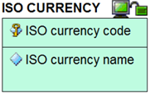

The third type is a relationship, or ‘foreign key constraint’. The lines between entities with the different symbols represent the different variants there are to these relationships. The relationships include ‘one to one’, ‘one to many’ and ‘many to many’. The exact relationship between the connected entities is described in words with a connecting phrase such as “qualifies the price of” or “is used by” or “contains allowed values for”. This connecting phrase will be contextual depending on the entities involved. | 
The variants of relationship differ from each other in other aspects:
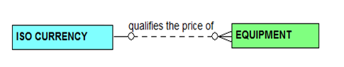 | Variant one: The identifier of the first entity is passed as a non-identifying element of the other entity.
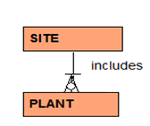 | Variant two: The identifier of the first entity is passed as an identifying element of the other entity. The line between the two entities is a solid line.
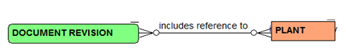 | Variant three: Many-to-many relationships. These typically require an intermediate entity to clarify the constraints
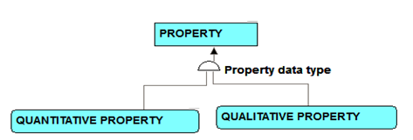 | Variant four: Subtyping – where multiple entities have the same identifier, but the subtypes need distinguishing from each other because they have different attributes.

For reference within the figures below, the following colour coding represents the source of the information:
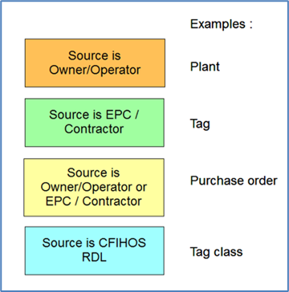
CFIHOS-SPTR-139

A.2.2 High-level views of the CFIHOS data model
This section provides examples from the CFIHOS data model. In order to understand the context of the entities that make up a capital facility and all the elements that are required in the handover of information, the following four extracts from the overall data model cover the key areas.
It is important to appreciate that even extracts of specialist areas of the model – e.g. the part covering documents and document metadata – is always a part of a bigger picture and the entities covered in one picture with the same name as those covered in another picture are, by definition, the same.

CFIHOS-SPTR-140
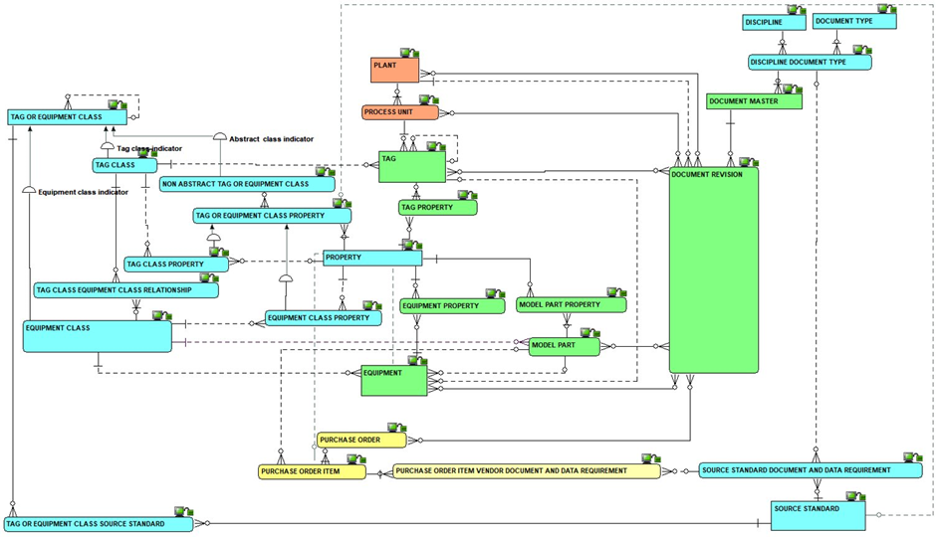
Figure A.1 – High-level overview of the complete model
CFIHOS-SPTR-141

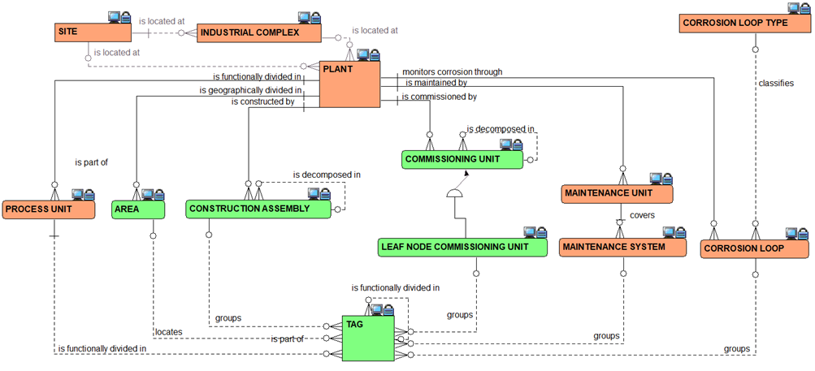
Figure A.2 – Overview of the Plant Breakdown Structure
CFIHOS-SPTR-142
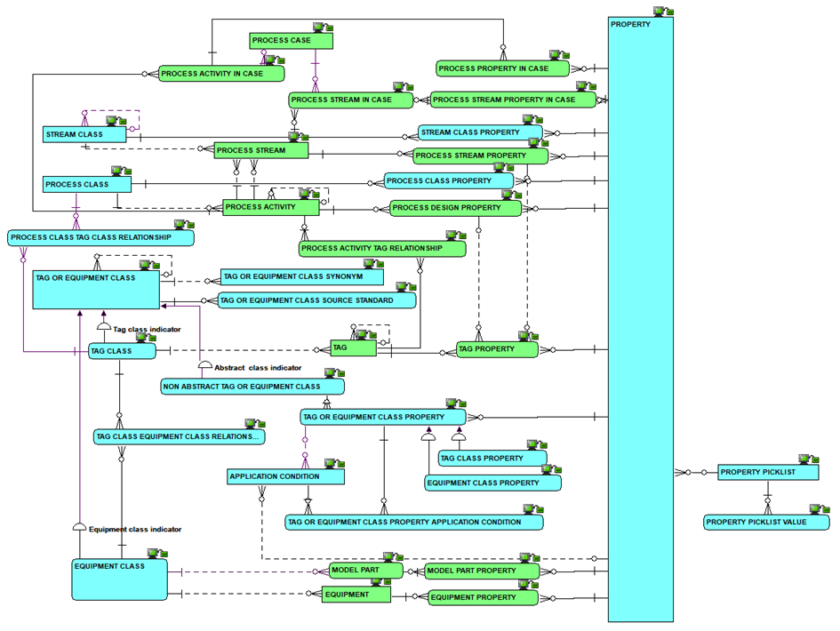
Figure A.3 – Overview of the Classifications and Properties including Processes, Streams and Cases
CFIHOS-SPTR-143
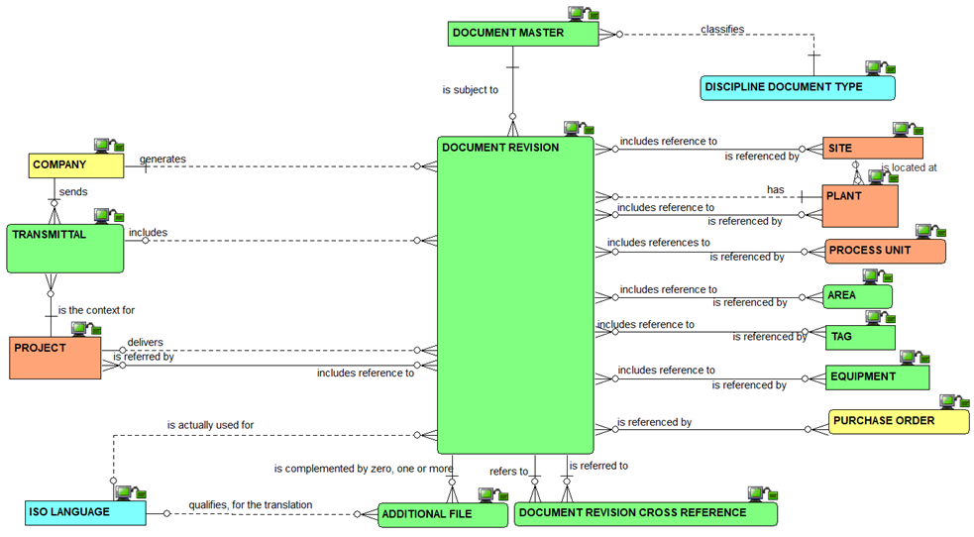
Figure A.4 – Overview of the document management metadata
CFIHOS-SPTR-144
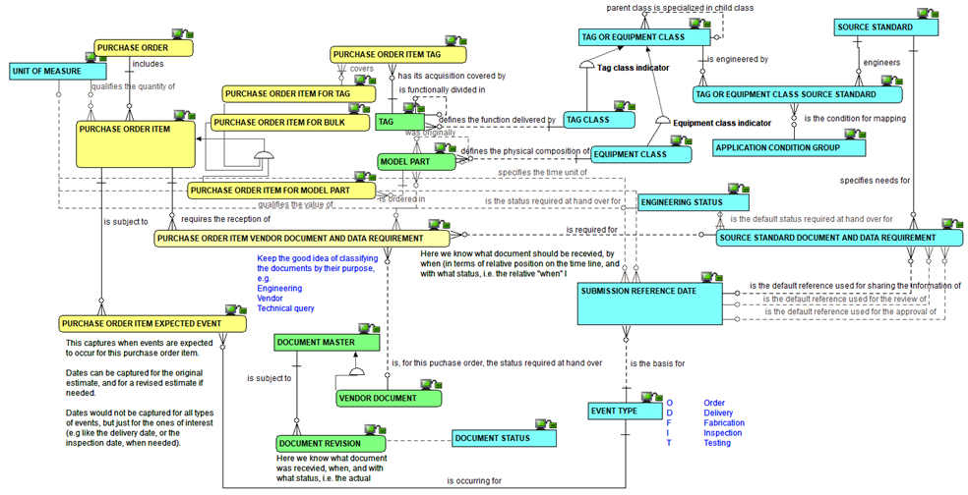
Figure A.5 – Overview of metadata requirements at time of procurement

CFIHOS-SPTR-145

A.2.3 Complete set of views of the CFIHOS data model
The complete data model is available in the following formats:
a) As a PowerPoint slide
b) In its native format.

Note: both versions come under the same document number [C-DM-001].

A.3 Data Dictionary
CFIHOS-SPTR-146

A.3.1 How to understand the data dictionary
For each CFIHOS Entity Object the data dictionary provides the list of attributes, with their definitions, examples, formats, optionality, constraints and sources.
Table A.1 describes the content of each column in the data dictionary.
CFIHOS-SPTR-147
Table A.1 – Data Dictionary Descriptions
Column | Field Name | Definition
A | Section | Provides a unique reference to each entity, with some mapping to the section used in the previous edition. Note: This column is not shown in the light version of the data dictionary, as it is replaced by the name of the related Entity for filtering.
B | Object | Indicates whether the row represents and entity or attribute within the data model.
C | Entity Filter | Allows the user to group by entity to see all the information for that entity together.
D | Name | The name of the entity (in the physical world: table) or attribute (in the physical world: column).
E | Definition | What the entity or attribute is/means/represents.
F | Note/ comment | Supplementary information about the entity or attribute, though not part of the definition.
G | Example | An example to assist in understanding.
H | Identifier/ Mandatory/ Optional | An indication whether the attribute is (part of) what identifies one occurrence of the entity, or, if not (part of- the identifier, whether the attribute is mandatory or optional.
I | Format | An indication of attribute’s data type and its maximum size.
J | Constraint | An indication of restrictions on allowable values of the attribute.
K | CFIHOS unique code | A code that, in CFIHOS, identifies uniquely an entity or an attribute. (Note: this column is not shown in the light version of the data dictionary).
L | Data source | An indication of where the data is sourced from:  - Principal  - Contractor/Supplier/manufacturer  - A mix of both  - Reference Data Library (RDL)  - RDL as a pick list
M | Former section (if different from last published version) | Indicates if the section code has changed since the last version. If it has the legacy value will be shown. If empty, there has been no change.
N | Relationship verb | Provides a description of the relationship to the entity referenced in the Constraint column.
CFIHOS-SPTR-148

A.3.2 CFIHOS Data Dictionary excerpt
Excerpt of the CFIHOS Data Dictionary provided below for reference:

A.4 Application Specific Data
CFIHOS-SPTR-149

A.4.1 Examples of Application Specific Data Deliverables
Table A.2 identifies some typical application specific data deliverables. This is not an exhaustive list and is meant to include examples for reference.
CFIHOS-SPTR-150
Table A.2 – Application Specific Database Examples
Application Specific Database Description | Application name and version  (intentionally left blank) | Handover Status
Development of the process simulation model or multi-purpose dynamic simulator (MPDS) and related deliverables, used for process plant design, production optimization, engineering modifications, operator training simulator. |  | As Design
Development of the 2D intelligent P&ID design application, used to generate ‘intelligent’ P&IDs, line list and related deliverables. |  | As Built
Development of the 2D Instrumentation design application data, used to generate loop diagrams, electrical signal I/O lists, instrument index, instrument specification sheets and input to the configuration of the plant automation systems. |  | As Built
Development of the 2D electrical design application, used to design distribution, single line drawings, specification Sheets, termination drawings and as input to electrical load simulations. |  | As Built
Development of the multi-discipline 3D Model design application, to facilitate clash free design, produce 2D drawings from the 3D master, generate MTO, facilitate construction management and operator training and development of digital twins. |  | As built
3D Structural or Pipe stress analysis models. |  | As Design
Editable backups of Plant Automation Systems and other configurations related the plant control, such as alarm management systems and Safety Instrumented Functions tools. |  | As Built
Blast analysis model, Gas dispersion studies, risk analysis model for use in safety studies, Safety Case amendments. |  | As Design
Geospatial Information System database for Pipelines and/or Subsea assets. |  | As Design
Spare Parts Database for definitions of Bills of Material, selection and procurement of spare parts. |  | As Built
Computerized Maintenance Management System Database, for the definition and management of Maintenance Plans and Maintenance Job Routines |  | As Built
Reliability Centered Maintenance Database, for optimization of maintenance strategies |  | As Built
Pressurized Equipment Integrity Management Database, For definition and management of inspection plans, and monitoring of corrosion rates |  | As Built
Risk Based Inspection Database for optimization of inspection strategies |  | As Built

Bibliography
CFIHOS-BIB-1
[1] EPISTLE Process Industry Data Handover Guide Part 1 and Part 2, issue 2.2 September 1998, Lewis & Thomson
CFIHOS-BIB-2
[2] NIST Capital Facilities Information Handover Guide, Part 1, NISTIR 7258 January 2006, Fallon & Palmer
CFIHOS-BIB-3
[3] Shell EIS Hand Over Specification, Engineering Information Specification (EIS) Design and Engineering Practice (DEP) 82.00.10.30-gen, Shell, February 2012.
CFIHOS-BIB-4
[4] CEN ORCHID Roadmap Standardising Information Across the Plant Engineering Supply Chain - Part 1: Direction and Framework , DS/CWA 16180-1, September 2010.
CFIHOS-BIB-5
[5] PISTEP Process Plant Engineering Activity Model, 1994, P Harrow
CFIHOS-BIB-6
[6] 3002007425 Rev 1, EPRI New Nuclear Power Plant Information Handover Guide, March 2016, R. King

